Title: Accounting for Human Connectivity in Social-Ecological Systems

**Authors:** Emma Fuller1*, Jameal F. Samhouri2, Josh Stoll3, James Watson4, Simon Levin1

**Affiliations:**

1 Department of Ecology and Evolutionary Biology, Princeton University, Princeton, NJ, USA.

2NOAA.

3University of Maine.

4Stockholm Resilience Centre

*Correspondence to: emma.cassel.fuller@gmail.com.

**One Sentence Summary:** To foster resilience in social-ecological systems, governance should quantify and account for the links people create when dependent on multiple components of an ecosystem.

**Main Text:** Understanding how to balance human well-being and ecological integrity is one of the fundamental challenges in conservation and natural resource management. As our human footprint on ecosystems expands and deepens, it becomes ever clearer that human well-being is crucial to understanding the dynamics of social-ecological systems and managing them sustainably. Despite the growing focus on valuing, and therefore measuring, human well-being alongside ecological quality indicators (i.e. biodiversity, ecosystem function), we still lack clear ways to operationalize these goals (1). Developing methods for understanding how people interact with their environment and ways to describe them is a major part of advancing sustainability science (2).

This challenge is particularly acute in commercial fisheries, where the dynamics of marine ecosystems and the well-being of fishermen are inherently tied to one another. Philosophically, the desire to account for connections between fish and fishers is present, as seen in numerous policy directives including the recently released NOAA Fisheries Climate Science Strategy and Ecosystem Based Fisheries Management (EBFM) technical reports (*3*, *4*). But while these policies call for the incorporation of the complexity and adaptive nature of these social-ecological systems into ocean management, attention to food-web interactions dominates, marginalizing the equally complex human networks resulting from how people participate and shift effort among fisheries. Developing new and innovative methods to understand these complex systems and their dynamics is therefore a critical, and largely unaddressed, step towards moving EBFM from theory to practice and ultimately advancing sustainability science (2). To this end, this paper presents an analysis of socioeconomic connectivity of the commercial fisheries in the California Current ecosystem that illustrates the diverse cross-fishery linkages that exist in coastal communities along the west coast of the United States. We focus on the California Current ecosystem because the natural science to support EBFM in this region is world class, yet little work has been done to account for human connections among fisheries that exist in the region.

To improve understanding of fishery linkages for policy makers, stakeholders and managers, we developed and applied a novel approach to build and describe participation networks. In doing so we find (i) general, consistent social linkages among fisheries that are currently unaccounted for in existing fisheries policy and management; (ii) that people diversify across jurisdictions/institutions (state and federal fisheries); and (iii) while there appear to be scale-invariant motifs in these networks, we find variation in the composition and structure from community to community suggesting heterogeneity in both the impact upon fishing communities, and their ability to deal with environmental, management, and/or market shocks.

This study presents a first effort to measure human linkages among commercial fisheries systematically. It validates the need for EBFM that embraces these connections in order to optimize benefits from fisheries, for instance by quantifying how ecologically distant taxa (e.g., benthic nearshore crab and offshore pelagic tuna) are tightly linked by the people who fish for them both. For example, measuring the impact of a crab closure alone would fail to account for the fact that 75% of the Dungeness crab fishermen are generalists, participating in an average of four other fisheries in a given year. Such generalism suggests the possibility of cascading effects across fisheries with a change in Dungeness crab management.

These participation networks also point to the value of governance structures that reflect the crossing of jurisdictional boundaries (*5*). For example, the state-managed Dungeness crab fishery is tightly connected to federal fisheries (i.e. on average crab fishers make 30% of their annual revenue on non-crab fisheries, 99% of these non-crab fisheries are federally managed). While governance that acknowledges cross-jurisdictional issues are not without precedent, as on the US West Coast where Pacific hake are jointly assessed and managed by the US and Canada, attention is rarely paid to human connectivity of fisheries across jurisdictions.

Last, quantitative measures of these networks provide the means to evaluate policy efficacy in the management of social-ecological systems. Across coastal communities in the US California current, network complexity varies five-fold. Simply naming this variability can help policymakers determine the extent to which a coast-wide management action (e.g. the recent implementation of catch shares in the groundfish fishery) will create comparable versus wildly different social and ecological consequences from place to place, in a way that would be impossible without observing human connectivity in the ecosystem.

We have focused here on recent ocean policy advances in the US, but the importance of quantifying human connectivity extends beyond American borders. Most regions supporting large industrial fisheries document diversity in the way fishermen distribute effort across marine resources (Australia, New Zealand, Baltic), not to mention highly diverse tropical subsistence fishing. Considering fisheries as network components linked together through the behavior of fishermen will help to advance understanding of ecosystem processes, implement ecosystem-level planning, prioritize vulnerabilities and risks, explore trade-offs of fisheries management alternatives, fully inform EBFM advice with ecosystem considerations, and develop operating protocols to maintain resilient ecosystems

Building methods that can operationalize goals of integrating human wellbeing and ecological integrity is one of the largest challenges in building sustainable social-ecological systems (1), and fisheries are no exception. We hope that by quantitatively illustrating the human connectivity of these systems and the connectivity across institutions and trophic levels, we can stimulate the development of operational policies that can be quantitatively assessed for their efficacy.

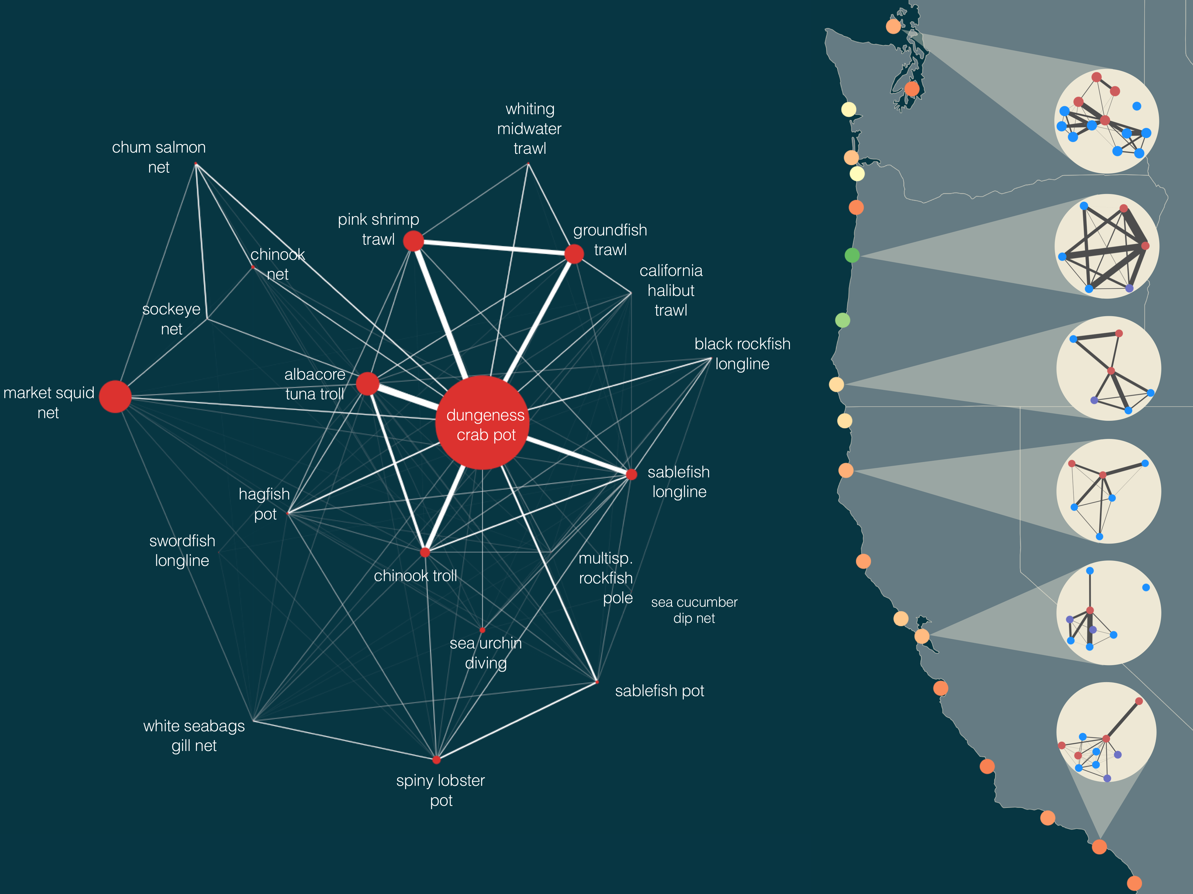

**Fig. 1. Human connectivity of commercial fisheries in the California Current Ecosystem.** Fisheries in the California Current are strongly connected by human participation. Some fisheries, notably the Dungeness crab-pot fishery, dominate the coast-wide network. The human connections among fisheries also frequently link ecologically distant species, i.e. Dungeness crab and Albacore Tuna or benthic groundfish and pink shrimp. Examining networks generated for port groups, we find that these networks vary in their structure in the number of fisheries (nodes), the heterogeneity in fishery size, and strength of interconnections. These differences in structure may correspond to differences in community resilience. We color ports using one potential metric of network resilience to highlight this heterogeneity. On the right port groups are colored by their adaptive capacity and show port-level participation networks with nodes colored by management jurisdiction (federally managed fisheries are blue, state managed are red, fisheries where both state and federal have a role in management, i.e. nearshore rockfish, are purple). For visual clarity we only include fisheries that had at least 3 vessels participating, and accounted for, on average, 25% of a vessel’s annual income (Materials and methods are available as supplementary materials at the Science website).

**References and Notes:**

1. G. M. Mace, Ecology. Whose conservation? *Science*. **345**, 1558–1560 (2014).
2. C. C. Hicks *et al.*, Engage key social concepts for sustainability. *Science*. **352**, 38–40 (2016).
3. J. S. Link, R. Griffis, S. Busch, “NOAA Fisheries Climate Science Strategy” (NOAA Technical Memorandum NMFS-F/SPO-155, 2015; http://spo.nmfs.noaa.gov/tm/).
4. J. S. Link, “Ecosystem-Based Fisheries Management Policy of the National Marine Fisheries Service National Oceanic and Atmospheric Administration” (National Marine Fisheries Service Policy Directive 01-120, 2016; http://www.nmfs.noaa.gov/op/pds/index.html).
5. L. B. Crowder *et al.*, Resolving Mismatches in U.S. Ocean Governance. *Science*. **313**, 617–618 (2006).
6. I. E. van Putten *et al.*, Theories and behavioural drivers underlying fleet dynamics models. *Fish and Fisheries*. **13**, 216–235 (2012).
7. W. J. Boonstra, J. Hentati Sundberg, Classifying fishers' behaviour. An invitation to fishing styles. *Fish and Fisheries*. **17**, 78–100 (2014).
8. Northwest Fisheries Science Center, "Data Analysis and Products". available at <http://www.nwfsc.noaa.gov/research/divisions/fram/observation/data_products/bottom_trawl.cfm#description)>.
9. N. Deporte, C. Ulrich, S. Mahevas, S. Demaneche, F. Bastardie, Regional metier definition: a comparative investigation of statistical methods using a workflow applied to international otter trawl fisheries in the North Sea. *ICES Journal of Marine Science*. **69**, 331–342 (2012).
10. J. Gao, B. Barzel, A.-L. Barabási, Universal resilience patterns in complex networks. *Nature*. **530**, 307–312 (2016).

**Acknowledgments:** Data for this analysis was provided by the Pacific Fisheries Information Network (PacFIN) database (www.psmfc.org). This work supported by funding from the National Science Foundation (GRFP, GEO-1211972).

Supplementary Materials:

Materials and Methods

References (*6-10*)

Supplementary Materials:

**Materials and Methods:**

Data

We collected vessel landings tickets for all commercial landings on the US West-Coast between 2006-2014 from the Pacific Fisheries Information Network (PacFIN) database (www.psmfc.org). These commercial landings accounted for approximately 2.7 million metric tons of 228 species, resulting in 3.7 billion dollars in revenue (adjusted to 2009 levels) by a total of 6,862 vessels. We discard any fisheries for which vessel-identifying information is unavailable, which precludes analysis of patterns of individual participation. This primarily affects bivalve fisheries (i.e. pacific oyster and geoduck fisheries in Washington).

Date preparation

To examine patterns of participation, we grouped landings into distinct fisheries. Fisheries are defined as harvest assemblages caught with a specific gear (*6*, *7*). The Pacific Fisheries Management Council (PFMC) has developed a set of sector-based definitions similar to this approach for the federally managed groundfish landings (www.pcouncil.org), but no equivalent exists for non-groundfish fisheries (*8*). In order to treat the landings dataset uniformly, we applied a métier analysis to this landing data (*9*) to build a set of fisheries.

Constructing Participation Networks

Fisheries are linked by fisher-mediated interactions. If a vessel *k* fishes in two fisheries *i* and *j*, they are linked in vessel *k*’s yearly strategy. Thus changes in fishery *i* can change the cost-benefit decisions for vessel *k* fishing in fishery *j*. The weight of the interaction between the two fisheries is determined by the density of the vessel linkages between fishery *i* and *j*. For a vessel *k*,link density scales with the amount of total revenue derived between the two fisheries *Rijk* and the evenness with which the vessel that participates in both fisheries *i* and *j,* but the more fisheries vessel *k* participates in, the smaller contribution to each fishery. So each vessel contributes to the link weight between fishery *i* and *j*. This results in a fishery-participation network

One limitation of using vessels as a proxy for individual fishermen is that it’s impossible to know if vessels changed hands. With a short enough time series, the risk of this might be slight, but with 8 years of data, it’s probable that at least some vessels were transferred. This is especially likely because some major changes occurred (i.e. the chinook salmon troll fishery closed and the general economic recession in 2008-2009; implementation of individual-transferable quotas in groundfish trawl fishery in 2011). Grouping across years, and across possible transfers in those cases, would smear the patterns of participation and obscure common subsets of fisheries that co-occur. To address the problem of vessel transfer, I split up vessels into vessel-year replicates.

To examine regional participation networks, we grouped landings by port-group. These port groups have been constructed to combine together ports that are part of the same fishing community (i.e. all San Diego-area ports).

Calculating Resilience

Using the universal resilience function from Gao et al. (*10*), for each network we calculated , where is the average edge weight across all, is the edge symmetry (here, because networks are undirected, symmetry is equal to one) and is the edge heterogeneity measured as variance in edge weights divided by .